* 1. List the Name and Designation code of the staff who have joined before Jan 2003 and whose salary range is between 12000 and 25000. Display the columns with user defined Column headers. Hint: Use As clause along with other operators

Query:

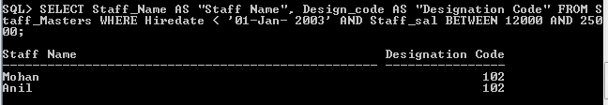

* 1. List the staff code, name, and department number of the staff who have experience of 18 or more years and sort them based on their experience.

Query:

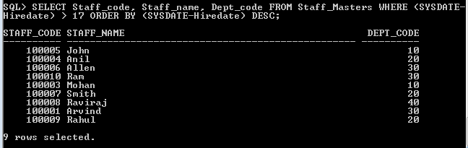

* 1. Display the staff details who do not have manager. Hint: Use is null

Query:

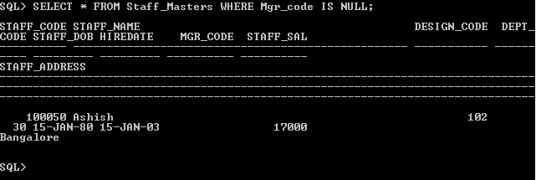

* 1. Display the Book details that were published during the period of 2001 to 2004. Also display book details with Book name having the character ‘&’ anywhere.

Query:

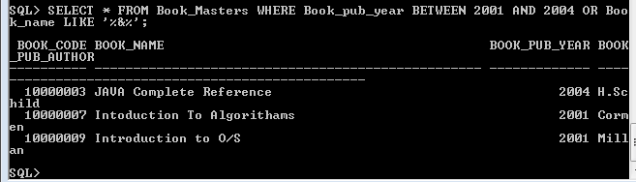

* 1. List the names of the staff having ‘_’ character in their name.

Query:

